GENERAL STUDY
HELPER BOT

Documentation and Project by Jomana Shaltout

Contents
Overview 3
Project Concepts and Plan 3
Project Processing 4
Project’s Present and Missing Features 4
Conclusion 5

Overview
The General Study Helper Bot is a simple chatbot that supports students in their studies. It gives automated messages on how to manage time, deal with stress, take notes and study effectively, and how to stop procrastination.

Project Concepts and Plan
In this program, the user will enter a phrase/question which will trigger an automated response from the bot. Below is an initial flowchart:
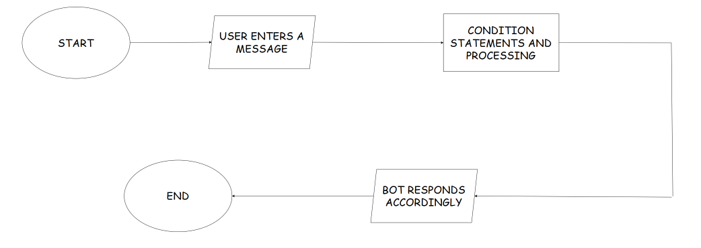
Figure 1: Initial Flowchart
This flowchart was created based on if the program would’ve been created using conditional statements like match-case (which I initially thought was different from using if-elif-else chain). However, after researching a bit more, the flowchart changed which had changed the approach of the program. Below is the new flowchart:
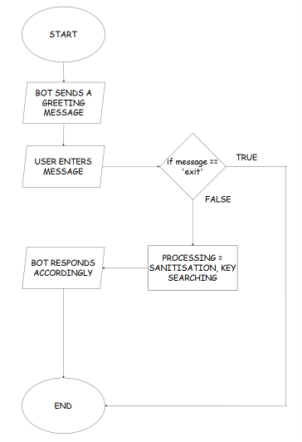
Figure 2: Final Flowchart
This flowchart displays a much better plan as it now shows that a loop will run until the user inputs ‘exit’.

Project Processing
Now that there are a clear plan and some concepts to the project, it’s time to talk about the processing. First, the data is stored in a Python Dictionary.
What data, and why in a dictionary? The data here is the keyword and the automated responses the bot will choose from depending on the user’s input. A dictionary was used as it has a better time complexity than conditional statements.
Second, the program is an IPO (Input-Process-Output) program, this means that there should be some processing done on the input before an output message is generated. Our message input is in string form, so sanitisation will be performed on the string.
What is sanitisation? Sanitisation is the process of cleaning the data so that the bot could easily check it. Because users are unpredictable, an input could come through as ‘HELLO ’, but the bot may not process it as it is stored as ‘hello’ instead of ‘HELLO’. Sanitisation here helps strip any excess leading or trailing spaces (using the .strip() method), and it also de-capitalises our string (using the .lower() method) to change our ‘HELLO ‘ to ‘hello’ before performing any other processing.
So, how is the dictionary used for the string values? Every specific keyword holds an automatic response. For example:
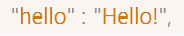
Figure 3: Dictionary Code
The figure above shows that if the user types ‘hello’, it will respond back with ‘Hello!’. Here, ‘hello’ is a keyword that’s searched for in the user input. The program uses the ‘in’ operator to check whether the keyword is present in the dictionary and if it is, it checks whether it’s present in the message input. This allows the bot to respond with the specified message, or otherwise if the keyword is not present in the dictionary.

Project’s Present and Missing Features
Below are two lists that contain the present features of the project, and the missing features.
Present Features | Missing Features
- A continuous loop that keeps the chatbot alive.  - A clean termination condition.  - Input sanitisation to handle case differences and accidental leading/trailing spaces.  - 7 intents covered: hello, studying effectively, exam stress, time management, note taking, procrastination, bye.  - Keywork scanning using in operator.  - Fallback response for unrecognised inputs.  - Greeting message on startup. | - Responds only the first keyword found and ignores the second one.  - Only supports exact keyword matching, it will not understand synonyms or misspellings.  - No follow-up handling.  - No handling for empty input  - No input length limit.  - No goodbye message before breaking.  - Study-related topics are limited.

Conclusion
This project helped me learn how a chatbot naturally responds to a user, and how much further a chatbot can improve to ease the user experience.

